Unit 5 Plants March ‘20 Name: ___________ ____________
Draw a plant and write the different parts of a plant. Then match them with the correct box.
ground shapes water plant sunlight minerals
Absorb ______ and _________ to grow and fix the plant to the_________.

1

Use the _________ to make food. They have different _______.
2 ______________

Carry water and minerals to the rest of the _______ and supports it.
3

Plants make their own f_______ in their l_________ through the process of p______________. To do this, plants need _______, ___________, ___________ d__________ and ______________.
Photosynthesis happens during the day/ night. During photosynthesis, plants eliminate carbon dioxide/ oxygen into the air. The water and minerals go up the soil/ stem. The leaves/ roots absorb water and minerals from the soil/sunlight.

Respiration / photosynthesis respiration / photosynthesis



_____________________________________________________________________________________
_____________________________________________________________________________________
_____________________________________________________________________________________

There are ____ different types of plants. Use 3 colours to match.
a) __________________ b _______________________ c _____________________

Tall plants with high branches
Low branches
Thin,flexible and short.
a soft stem
A trunk
A thick , hard stem
Can be deciduous or evergreen

Classify the leaves according shape, margin and arrangement. Look at the chart and complete the information.
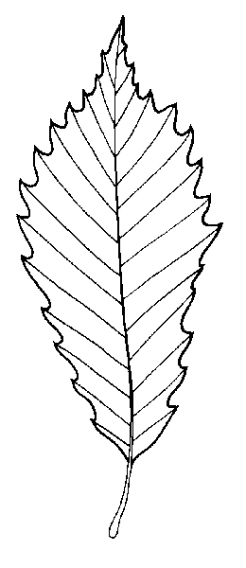
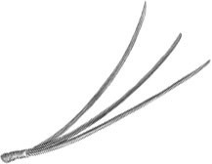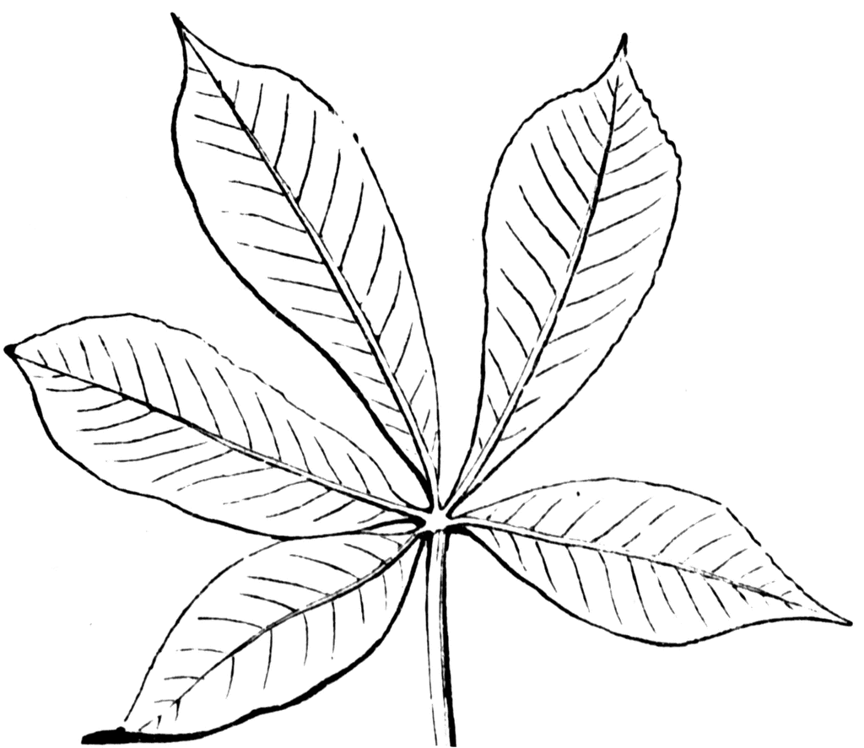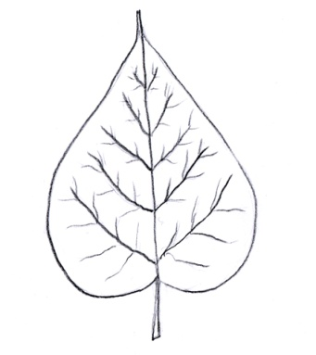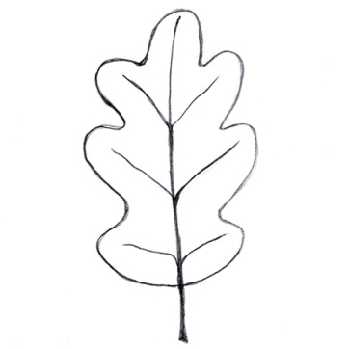

Leaf A is _____________ shape, ______________ margin and ______________ arrangement.
Leaf B is _____________ shape, ______________ margin and ______________ arrangement.
Leaf C is _____________ shape, ______________ margin and ______________ arrangement.
Leaf D is _____________ shape, ______________ margin and ______________ arrangement.
Leaf E is _____________ shape, ______________ margin and ______________ arrangement.

