FOOD CHAINS
A food chain is how living things in a ecosystem depend on each other for food. What eats what to live.
All the elements in the food chain are necessary. If one element disappears, the food chain
doesn´t work. For example, in a grassland we can find this food chain:
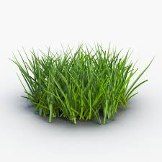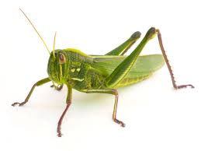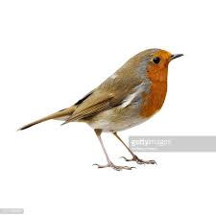

GRASS GRASSHOPPER BIRD
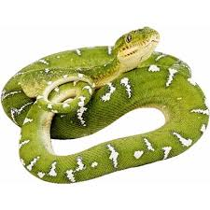
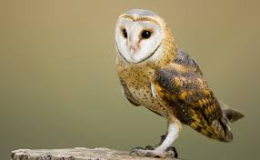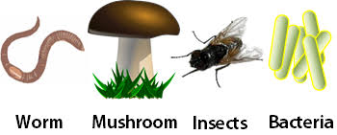
SNAKE OWL DECOMPOSERS

The grass is eaten by the grasshopper, The grasshopper is eaten by the bird,
The bird is eaten by the snake, The snake is eaten by the owl.

In the food chain, the grass is the producer.
The grasshopper (hervibore animal) is the primary consumer.
The bird (omnivore animal) is the secondary consumer.
The snake (carnivore animal) is the tertiary consumer.
The owl is (carnivore animal) is the ultimate consumer.

A prey is an animal that is eaten by another animal: grasshopper, bird and snake.
A predator is an animal that eats another animal: bird, snake and owl.

