Tuesday 19th May 2020
Matter
The Universe is made up of matter. Matter has 3 different states: solid, liquid and gas.
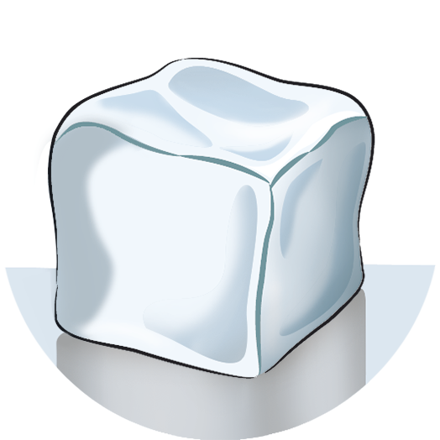
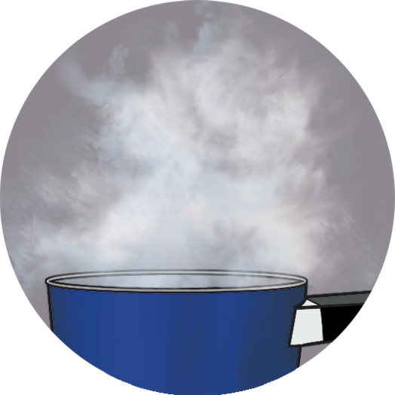
solid liquid gas

Matter includes mass and volume.
Mass is how much matter something has. We measure it in g/kg.
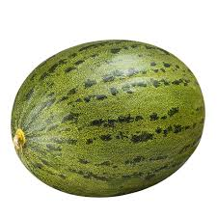
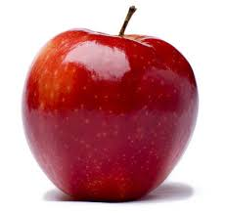
Volume is how much space something occupies. We measure it in ml/l.
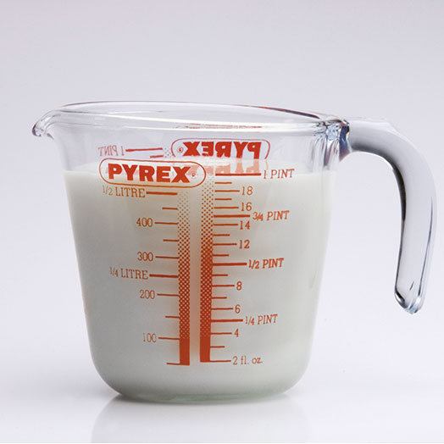
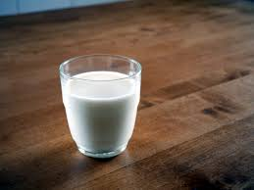
jug of milk a glass of milk

 | mass | volume
solids | have definite mass | have definite volume
liquids | have definite mass | have no definite volume
gases | have no definite mass | have no definite volume

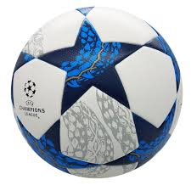
a bowling ball a football
The bowling ball has more mass, but a football has more volume.

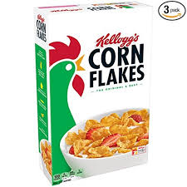
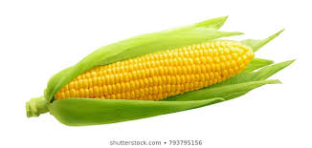
a box of cereals an ear of corn
An ear of corn has more mass, but the box of cereals has more volume.

